# Memphis Redbirds – Campaign Part 2: Content Plan (Top‑tier revision)

**Course:** Digital Marketing (DMK) • **Student:** Austin Humphrey • **Assignment:** Part 2 (Content) • **Focus:** Sales (single‑game tickets & merchandise)

## Campaign Objective

This campaign aims to **prompt sales** by driving **15,000 single‑game ticket purchases** and **$75,000 in merchandise revenue** over a 12‑month period. The objective is anchored in the course guidelines, which note that sales‑focused campaigns should prioritize direct‑response channels and measure success through conversions and cost per acquisition【470621841872899†screenshot】.

## Marketing Channels

The plan leverages **three digital channels**—email marketing, paid search, and social media advertising—supplemented by **two traditional channels** (local radio and outdoor billboards). According to the assignment instructions, campaigns with a sales objective benefit from channels like email, paid search, and display/social ads because they target users with high purchase intent【470621841872899†screenshot】.

### Email Marketing (Mailchimp)

* **Platforms & tools:** Mailchimp will manage a subscriber database exceeding 12,000 contacts. Lists will be segmented into families, young adults, Cardinals‑affinity fans, and lapsed attendees. Automated flows include a welcome series, game‑day reminders, post‑game thank‑you emails, and cart recovery.
* **Strategic rationale:** Email captures known audiences and nurtures them toward purchase. Each message will include dynamic content based on the recipient’s segment (e.g., family‑friendly offers, “Thirsty Thursday” passes). This channel aligns with the sales objective by driving direct traffic to purchase pages.
* **KPIs & optimization:** Industry benchmarks from Mailchimp report an average open rate of **35.63%** across all users【873383993367484†L369-L376】. The campaign targets a **35% open rate** and **$4.50 revenue per email** by A/B testing subject lines, send times, and template variants. Conversion tracking will measure revenue per send and cost per conversion.
* **Engagement & retargeting:** Monthly “Fan of the Month” spotlights, interactive polls, and behind‑the‑scenes videos encourage ongoing engagement and repeat visits. All emails link to mobile‑optimized landing pages with one‑click checkout.

### Paid Search (Google Ads)

* **Setup:** Create campaigns around brand terms (e.g., “Memphis Redbirds tickets”), non‑brand keywords (“baseball tickets Memphis”), event‑specific promotions, and merchandise. Employ value‑based bidding to optimize for conversions and ROAS.
* **Dayparting & geo:** Target lunchtime and early evening search traffic (11 AM–1 PM and 4–8 PM) when users plan evening activities. Geo‑target the Memphis metro and surrounding counties.
* **CTA & KPIs:** Ads direct to dedicated landing pages featuring seat selectors and clear “Select Your Seats” calls to action. Negative keywords (e.g., “jobs,” “youth league”) focus the budget on buyers. The campaign aims for a **sub‑$8 cost per ticket acquisition** and **>2.8% conversion rate**.

### Social Media Advertising (Meta & Instagram)

* **Platforms & tools:** Use Facebook and Instagram as primary platforms, managed via Meta Ads Manager; experiment with TikTok for Gen Z reach. Implement the Facebook Pixel to retarget website visitors.
* **Content & CTA:** Top‑funnel video ads highlight the ballpark atmosphere; mid‑funnel carousel ads showcase theme nights; bottom‑funnel dynamic ads display real‑time ticket availability with *“Buy Now – Only X Seats Left”* calls to action.
* **Audience architecture & optimization:** Build lookalike audiences from past buyers and engaged video viewers, layering Memphis‑related interests. Target a **6% engagement rate** and **<$10 cost per conversion**. Weekly creative refreshes prevent fatigue and ensure relevance.
* **Engagement:** User‑generated content campaigns (e.g., #RedbirdsNation) encourage fans to share photos, while live Q&A sessions maintain connection between games【343048386840876†L570-L600】.

### Local Radio

* **Strategy:** Partner with Memphis stations such as 92.9 ESPN, 98.1 The Max, and Soul Classics 103.5 to air 30-second and 15‑second spots during morning and afternoon drive times. Each spot includes a simple vanity URL (“RedbirdsTickets.com”) and promo code (e.g., “RADIO15”) to track response.
* **Measurement & optimization:** Unique promo codes and station‑specific landing pages allow cost‑per‑response analysis. The goal is a **3% response rate**; emotional and rational messaging will be tested to determine which resonates best with audiences.

### Outdoor Billboards

* **Placement & creative:** Deploy digital billboards at high‑traffic intersections (Poplar/I‑240 and Union/McLean). Creative rotates every two weeks, featuring simple copy (“Opening Night – April 5”) and QR codes for measurement.
* **Integration:** Billboards will be paired with geofenced mobile retargeting so that drivers who pass a board receive follow‑up ads on social platforms. The objective is a **0.8% QR scan rate** and an uplift in website sessions from targeted zip codes.

## Content Strategy & Editorial Calendar

The Redbirds will operate like a publisher, delivering a steady cadence of informative and entertaining content that motivates purchases. A representative month of cross‑channel activity is outlined below. Each element supports the sales objective by encouraging ticket or merchandise transactions.

| Week | Blog & long‑form | Social media | Email | Traditional |
| --- | --- | --- | --- | --- |
| **Week 1** | Behind‑the‑scenes article on Opening Day preparations | Video introductions to players and stadium transformations; create a Facebook Event for Opening Night | Welcome series: “2024 Season Starts Now” with exclusive discount code | Radio live remote from AutoZone Park; billboard: “Baseball Returns April 5” |
| **Week 2** | Family guide to enjoying Redbirds games (parking, kids’ zones, concessions) | Infographic on ticket affordability; launch #MyRedbirdsStory UGC campaign | Segment‑specific emails: families receive “Kids Eat Free Sunday” offer; young adults receive “Thirsty Thursday” passes | Radio spots promoting family nights; billboard creative highlighting theme nights |
| **Week 3 (Rivalry Week)** | Feature on the Memphis–Nashville rivalry | Prediction contest; Twitter Spaces discussion with Nashville media; Instagram Stories from fans | Email: “Rivalry Week Package” offering discounted multi‑game bundles | Increased radio frequency with hourly updates; billboard: “Memphis vs. Nashville – Pick Your Side” |
| **Week 4** | Article profiling rising stars poised for the majors | Monthly highlight reel; Facebook Live with the manager; TikTok challenges with the mascot | Email: Monthly roundup and flash sale | Weekend “Redbirds Replay” radio show; postcards mailed to neighborhoods near AutoZone Park |

## Mock‑ups

Below are three conceptual mock‑ups demonstrating how the creative might appear across different channels. The designs harness team colors and the excitement of a live game while integrating clear calls to action.

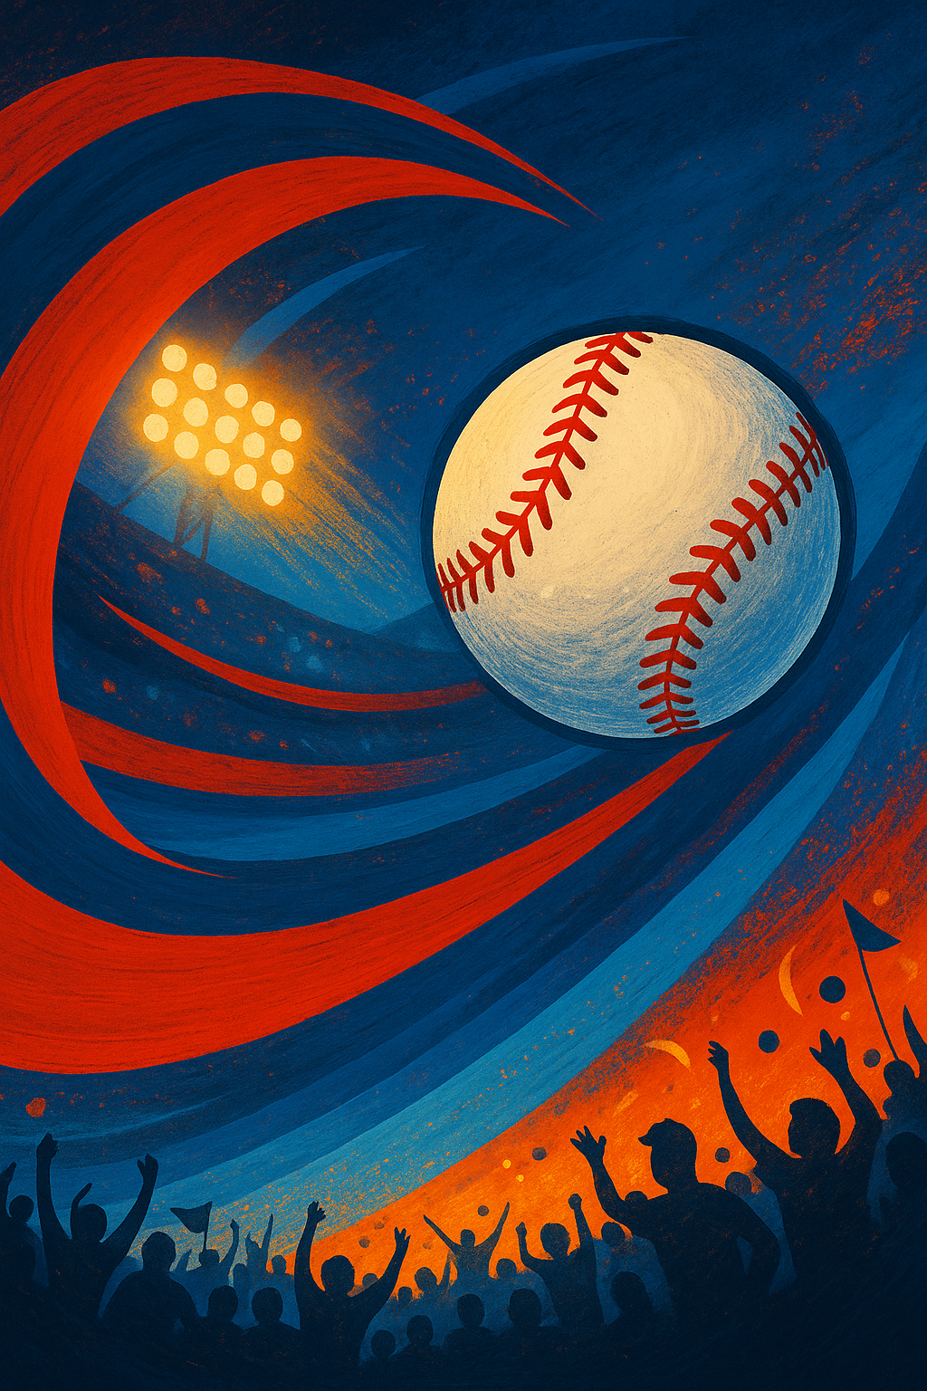

Social media ad concept

*Figure 1: A social media ad concept for Facebook/Instagram. Bold team colors, a dramatic baseball motif, and a clear “Get Your Tickets!” call to action guide viewers toward purchase.*

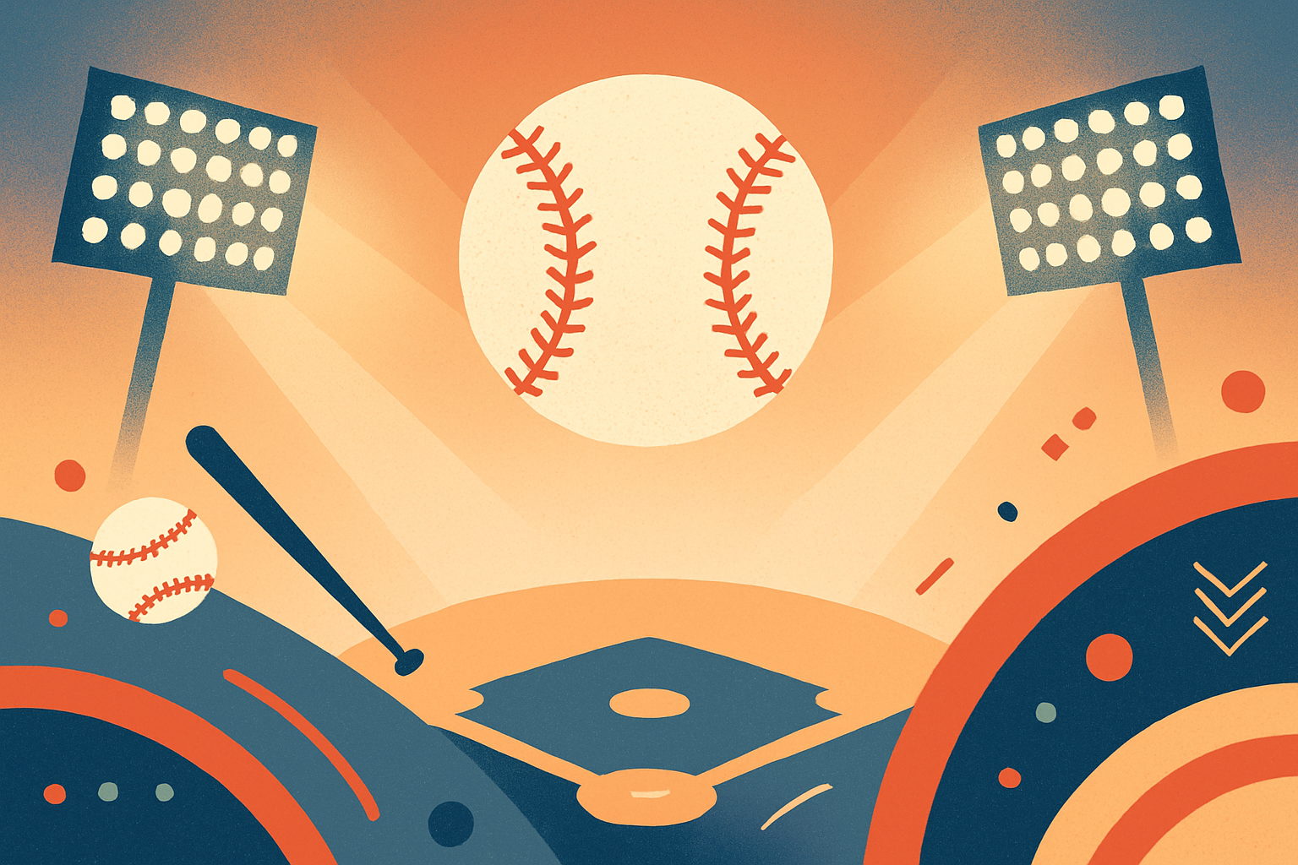

Email header design

*Figure 2: An email header design conveying a ballpark atmosphere. It anchors the newsletter’s content and directs readers toward ticket and merchandise links.*

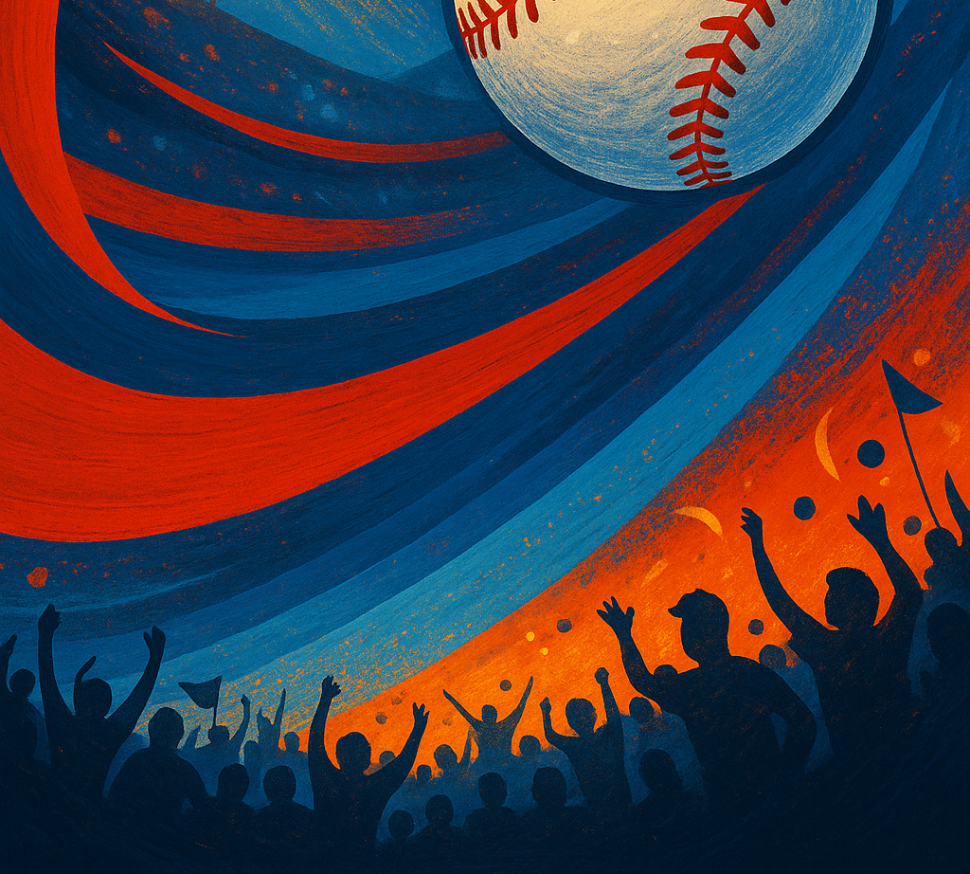

Billboard concept

*Figure 3: A billboard concept adapted for outdoor advertising. High‑contrast visuals and minimal text ensure legibility for drivers while promoting upcoming games.*

## Measurement & KPIs

A data‑driven dashboard will track performance across channels. Primary metrics include:

* **Conversion metrics:** cost per acquisition (target <$8 per ticket), return on ad spend, conversion rate, and revenue per email.
* **Engagement metrics:** email open rate (target 35%【873383993367484†L369-L376】), click‑to‑purchase rate (>4%), social media engagement (>6%), and follower growth.
* **Traditional response:** response rates to radio promo codes (>3%) and billboard QR scans (>0.8%).
* **Secondary metrics:** customer lifetime value, repeat purchase rate, net promoter score, and share of voice in local sports conversations.

## References

1. Full Sail University. (2025). *Assignment 2.3: Digital Marketing Campaign Guidelines*. [Course materials]. Guides on selecting a sales‑focused objective and recommended channels【470621841872899†screenshot】.
2. Mailchimp. (2024). *Email Marketing Benchmarks & Industry Statistics*. Retrieved from https://mailchimp.com/resources/email-marketing-benchmarks/. Reports that the average open rate across all users is 35.63%【873383993367484†L369-L376】.
3. Sports marketing – Wikipedia. *Social media in sports marketing*. Discusses how social media enables sports organizations to engage fans and build loyalty【343048386840876†L570-L600】.